This article contains images from the Grand Teton National Park Summit Register archive for some of Fred Beckey’s climbs in the range. I’ve included a transcription of each summit register entry for clarity sake.

**July 1939 Trip in the Teton Range**

The first set of summit register entries are from a trip in 1939, and I found entries for all the peaks they climbed during this trip. Fred was 16 years old at the time and his brother Helmy was 13 years of age.

From their camp in Garnet Canyon, Ernst Kassowitz, Helmy and Fred Beckey first climbed Middle Teton, followed by South Teton on July 15, 1939. Fred Beckey and Ernst Kassowitz then climbed Cloudveil Dome later on the same date.

**Middle Teton Summit Register entry**

7/15/39 Time 3 hrs 40 min. fron Garnet Camp

“ Helmy Beckey Seattle, Wash

“ Fred Beckey Seattle, Wash (Mtneers)

“ Ernst Kassowitz Seattle, Wash

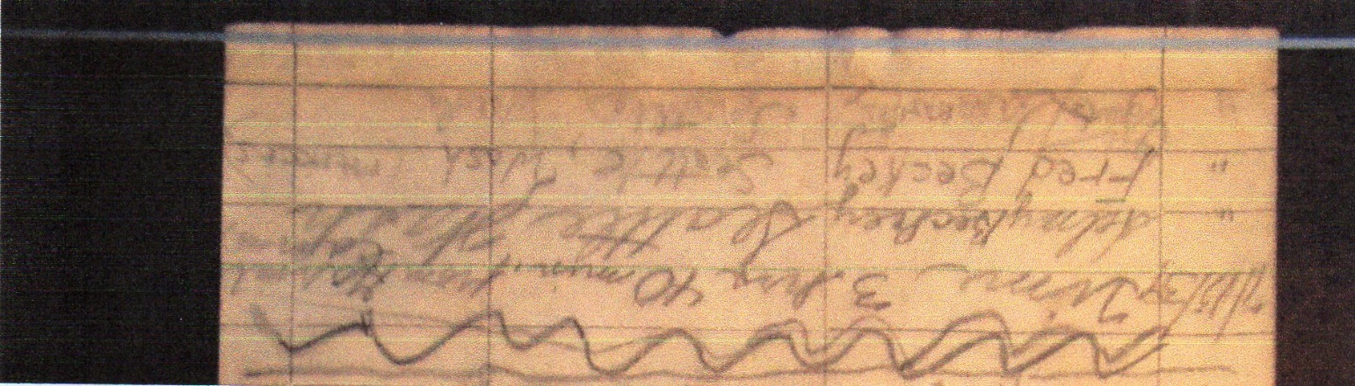

Image from Grand Teton National Park Summit Register archive, Middle Teton.

**South Teton Summit Register entry**

First ascent of 1939

Time from saddle 45 min

After climbing Middle

Peak. Arrived on top 11:30 AM

Helmy Beckey, Seattle, Wash.

Fred Beckey - Seattle, Wash.

Ernst Kassowitz - Seattle Wash.

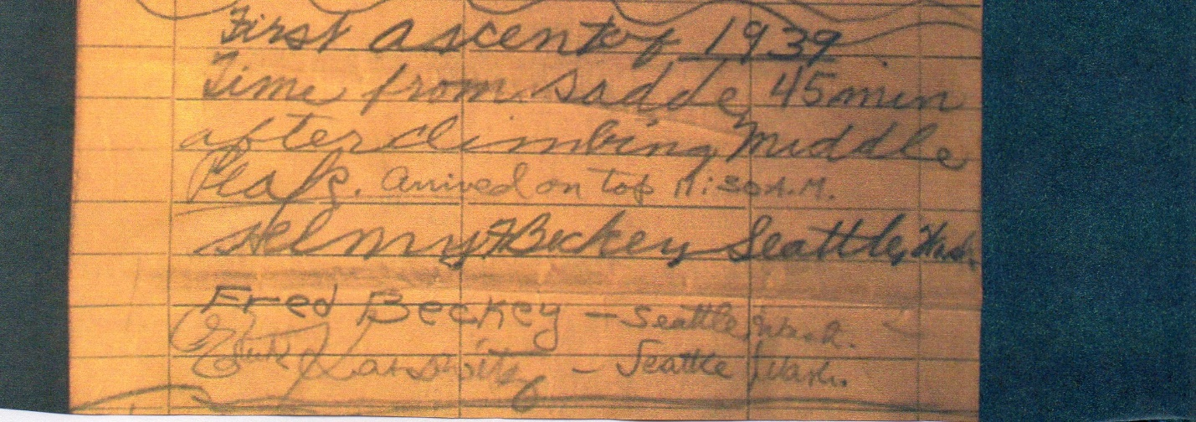

Image from Grand Teton National Park Summit Register archive, South Teton.

**Cloudveil Dome Summit Register entry**

7/15/39 Fred Beckey – Seattle, Washington

Ernst Kassowitz – Seattle, Wash.

Climbed Middle & South Tetons and

!!! ~~traversed ridge to here.~~ (3:30 PM)

Not sure, did only South and Cloudveil

without traversing the ridge

Image from Grand Teton National Park Summit Register archive, Cloudveil Dome.

**Nez Perce Summit Register entry.**

On September 16th, 1939, Ernst Kassowitz, Helmy and Fred Beckey climbed Nez Perce from Garnet Canyon.

7/16/39 Fred Beckey Seattle, Wash.

“ Helmy Beckey “ “

“ Ernst Kassowitz “ “

Climbed from N.W.

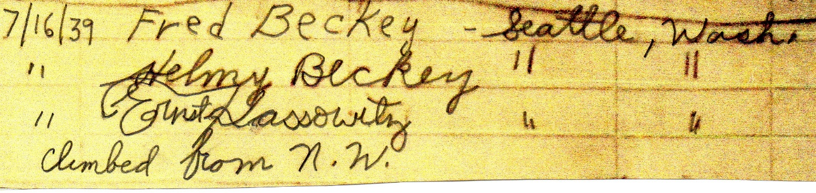

Image from Grand Teton National Park Summit Register archive, Nez Perce.

**Grand Teton Summit Register entry.**

On September 17, 1939, a large group guided by Glenn Exum, including Helmy and Fred Beckey, climbed the Grand Teton via the Owen-Spalding route.

July 17, 1939 Hubert Scholl Milwaukee, Wis.

Helmy F. Beckey age 13 Seattle, Wash.

Ernst Kassowitz Seattle, Wash.

Fred Beckey Seattle, Wash.

Dr. Karl Erhurel Kassowitz Wauwatosa, Wis.

Verena Kassowitz Wauwatosa, Wis. 14 yrs

Karl Vernon Kassowitz Wauwatosa, Wis. 16 yrs

very enjoyable and novel experience.

Glenn Exum - S.A.C.

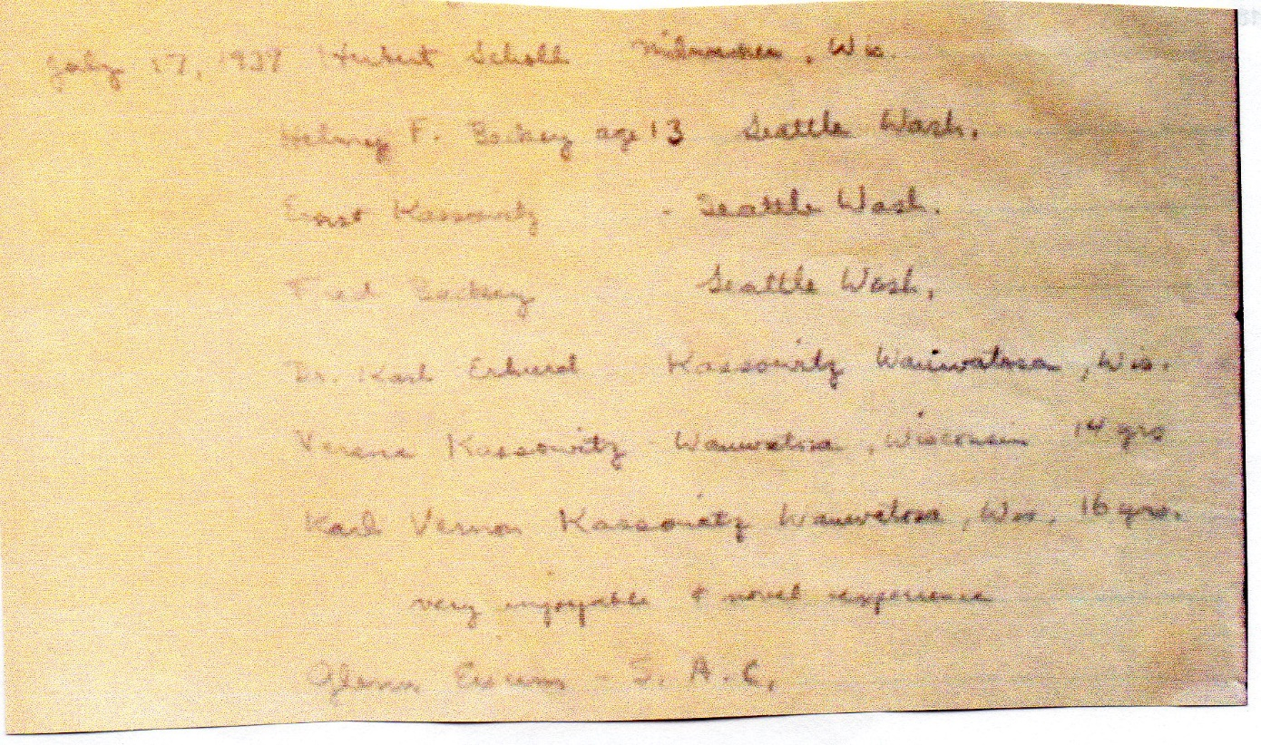

Image from Grand Teton National Park Summit Register archive, Grand Teton.

**Teewinot Summit Register entry.**

On July 19, 1939, Helmy and Fred Beckey climbed Teewinot. Because of water damage, someone transcribed all the summit register entries for the peak in 1939, at a later date.

(July) 19 Fred Beckey - Seattle, Wash.

Helmy Beckey “ “

Image from Grand Teton National Park Summit Register archive, Teewinot.

**The Tooth Summit Register Entry.**

The climbing trip to the Teton Range was the first climbing trip the Beckey brothers took outside the state of Washington. When they returned to Seattle, Helmy and Fred Beckey climbed The Tooth in the Cascade Range on July 29, 1939. Fred signed in as follows, proud of his climbing accomplishments in the Teton Range.

July 29, 1939

Perfect weather & view.

Climbed S.E. face. - not bad.

Fred W. Beckey (the Teton

Boy.)

Helmy Beckey age 13

University of Washington Libraries, Special Collections of Mountaineers summit registers, 1907-2015. Accession No. 2013-009, Container 8.

**Mt Owen Summit Register entry**

On September 9, 1959, Yvon Chouinard and Fred Beckey established a new route on Mt Owen via the Crescent Arete. Two days earlier Beckey climbed for the first time with Chouinard, when they joined forces with Ken Weeks to establish a new route on the east face of Table Mountain in the Teton Range.

9/9/59 YVON CHOUINARD

FIRST ASCENT OF THE CRESCENT ARETE

FRED BECKEY – Seattle, Wn. 8 hours

from Jenny Lake

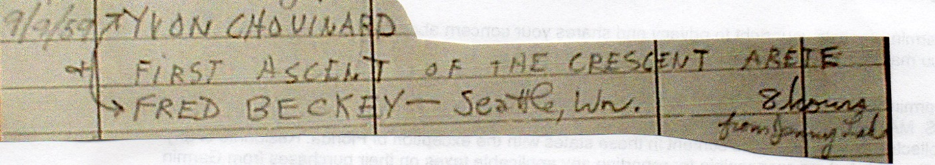

Image from Grand Teton National Park Summit Register archive, Mt Owen.

**Mt Moran Summit Register entry**

On September 10, 1962, Dan Davis and Fred Beckey established a new route on Mt Moran via the NE Slabs. Dan Davis did 20 climbs with Fred Beckey in 1962, only two of these climbs were not a new route or first ascent.

9/10/62 Probably first ascent

of the NE slabs

DAN DAVIS (NWB)

Fred Beckey (FBCC)*

The Northwest branch

strikes again (one member

present)

*FRED BECKEY CLIMBING CLUB

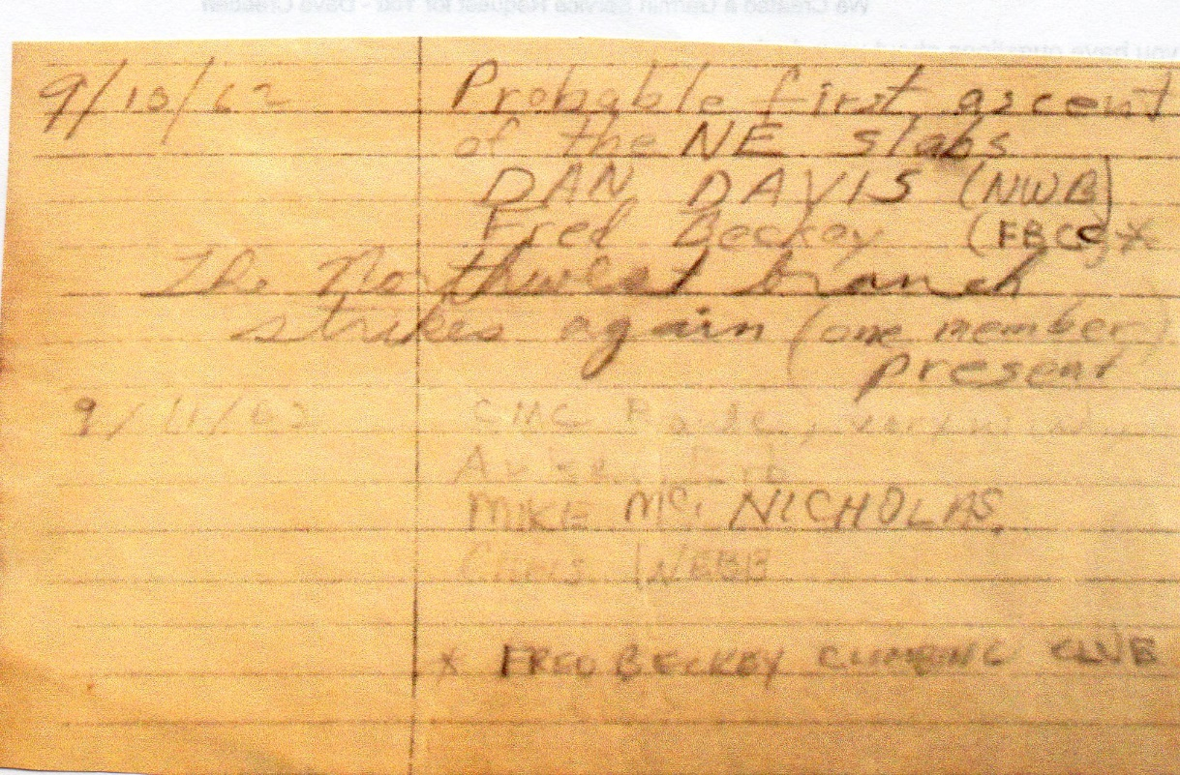

Image from Grand Teton National Park Summit Register archive, Mt Moran.

Below is Dan Davis’s summary of this climb from his climbing journal.

Image from *Dan Davis* *Climbing Journal 1959 to 2005.* University of Washington Libraries, Special Collections.

**Grand Teton Summit Register entry**

On July 26, 1963, the triumvirate of Dan Davis, Steve Marts and Fred Beckey climbed the North Ridge of the Grand Teton. Steve Marts, like Dan Davis, was a frequent climbing partner of Fred Beckey during 1962-1963. Marts and Beckey were only unsuccessful on one climb together and nearly 70% of the climbs they did together were a new route or first ascent. This climb of the north ridge of Grand Teton was one of the rare ascents which was not a new route or first ascent.

July 26 DAN DAVIS Seattle via N. Ridge

Fred Beckey enjoyable

Steve Marts climb

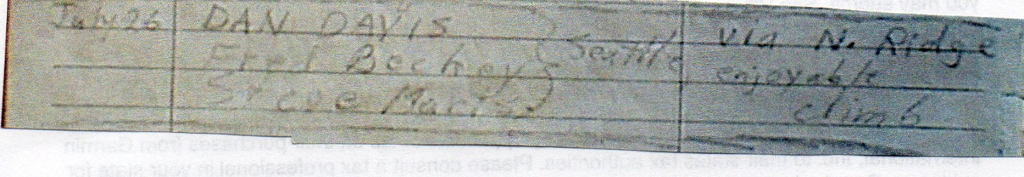

Image from Grand Teton National Park Summit Register archive, Grand Teton.

Below is Dan Davis’s summary of this climb from his climbing journal.

Image from *Dan Davis* *Climbing Journal 1959 to 2005.* University of Washington Libraries, Special Collections.

Author: Dave Creeden.